NATIONAL UNIVERSITY OF MODERN LANGUAGES
Lab report

SUBMITTED BY:
ZULQARNAIN HASSAN

SUBMITTED TO:
SIR. M WAQAR
Subject: ……………………………………….. Data Structure and algorithm
Roll No: ………………………………………… SP21379
Department: …………………………………. Software engineering
Section: …………………………………………. BSSE-III-A-afternoon
Submission date……………………………..5th may, 2023

Lab 01
Array Data Structure
Program 01
#include<iostream>
using namespace std;
int main()
{
int array[5];
cout<<"enter 5 digits\n";
for(int i=0;i<=4;i++)
{
cin>>array[i];
}
for(int j=0;j<=4;j++)
{
cout<<"Number"<<j+1<<" : ";
cout<<array[j]<<endl;
}
}
Output:
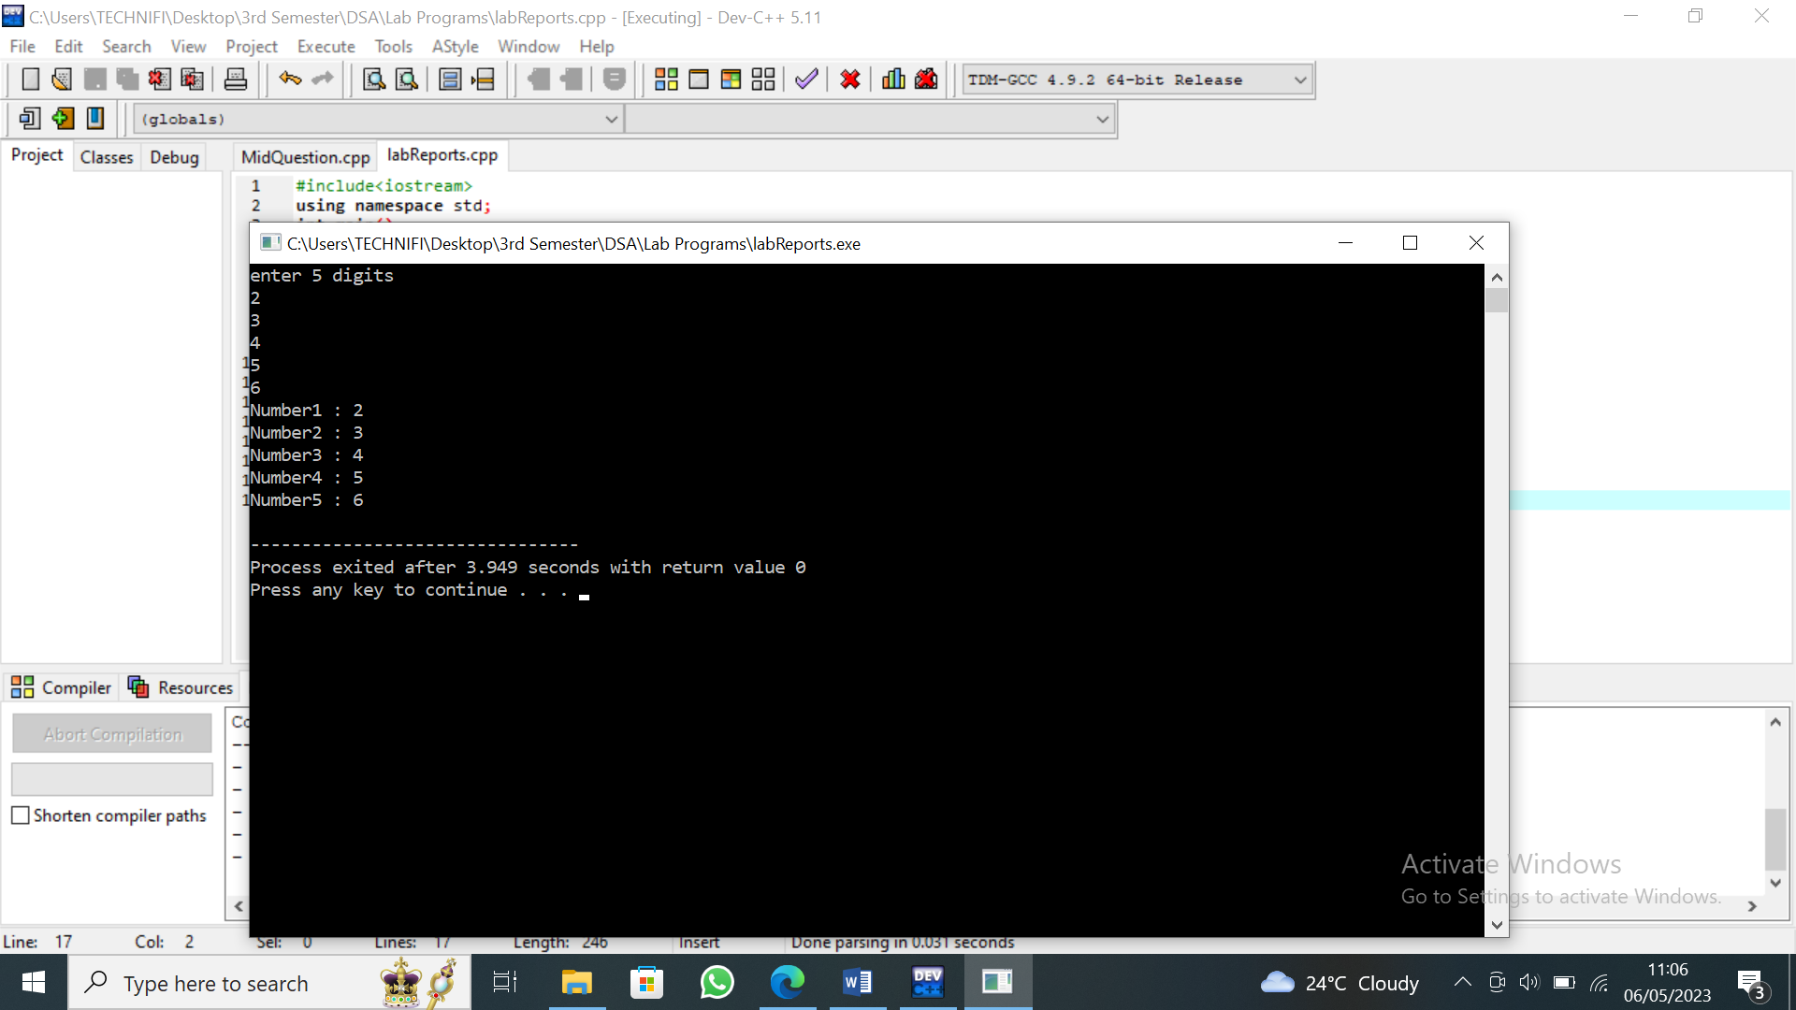
Program 2
#include<iostream>
using namespace std;
int main()
{
int array[5];
cout<<"enter 5 digits\n";
for(int i=0;i<=4;i++)
{
cin>>array[i];
}
int t=0;
for(int j=0;j<=4;j++)
{
if(array[j]==5)
{
t++;
}
}
if(t==0){
cout<<"not found";
}
else
{
cout<<"found";
}
}
Output:
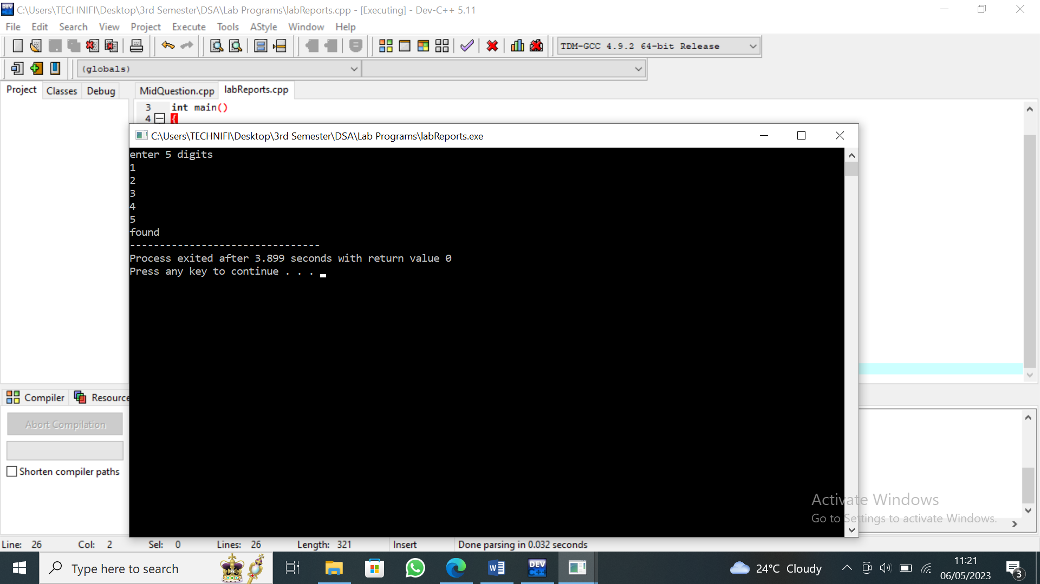
Program 3
#include<iostream>
using namespace std;
int main()
{
int array[5];
cout<<"enter 5 digits\n";
for(int i=0;i<=4;i++)
{
cin>>array[i];
}
int num;
int f=5;
int l;
int t=0;
for(int j=0;j<=4;j++)
{
if(array[j]==f)
{
num=array[j];
t++;
l=j;
}
}
if(t==0){
cout<<"not found";
}
else
{
cout<<"found number "<<num<<" at indux "<<l;
}
}
Output:
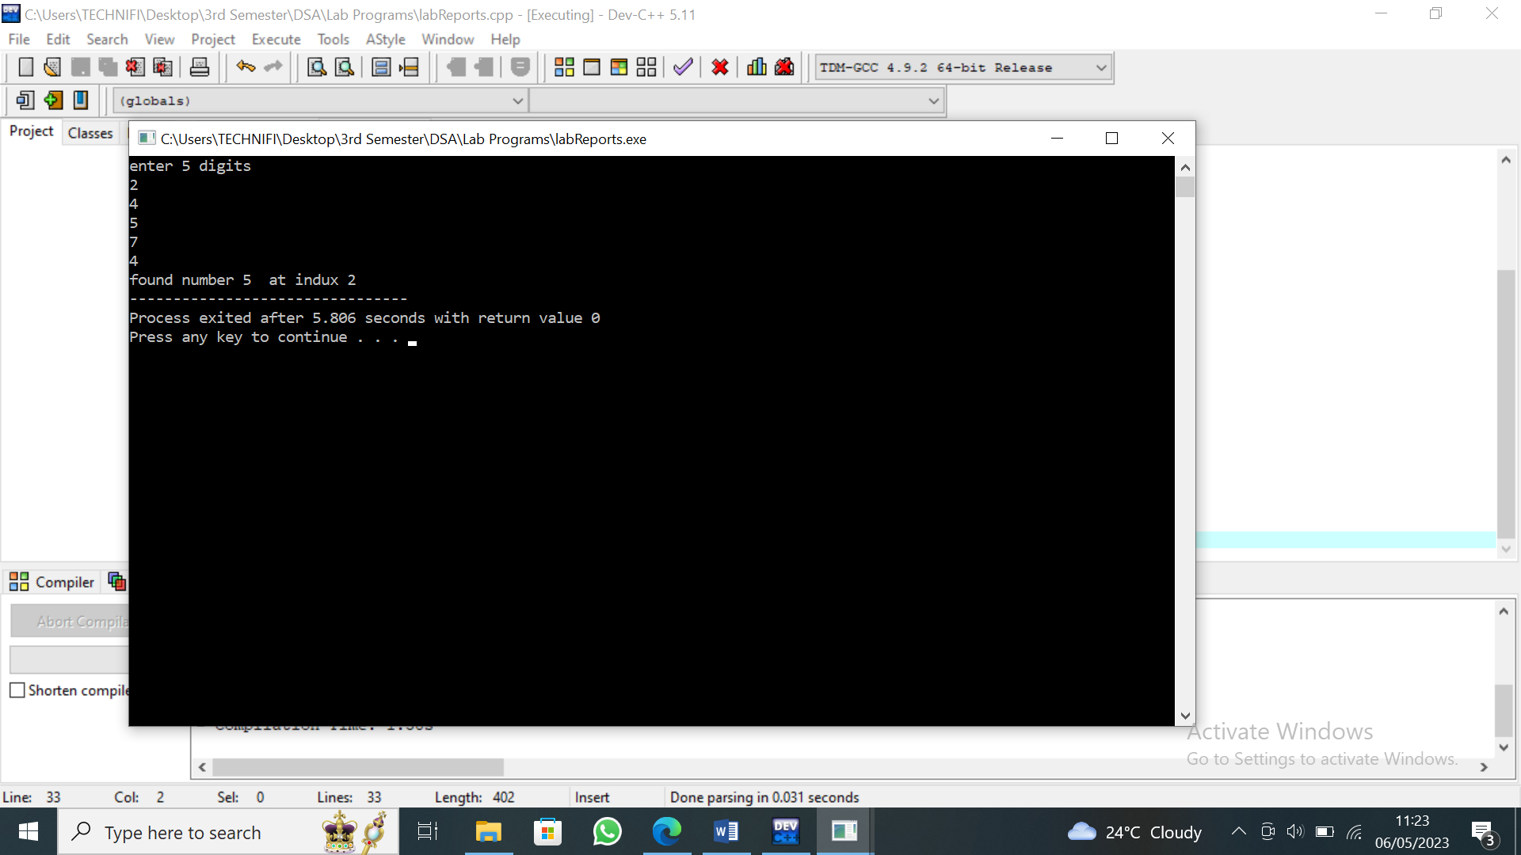
Program 4
#include<iostream>
using namespace std;
int main()
{
int f;
int k=0;
int array[5];
cout<<"enter 5 digits\n";
for(int i=0;i<=4;i++)
{
cout<<"Enter "<<k++<<" index: ";
cin>>array[i];
}
cout<< "Enter the number that you want to find: ";
cin>>f;
int num;
int l;
for(int j=0;j<=4;j++)
{
if(array[j]==f)
{
num=array[j];
l=j;
}

}
cout<<"you found "<<num<<"at index "<<l<<endl;
cout<<" before :"<<l--;
}
Output:
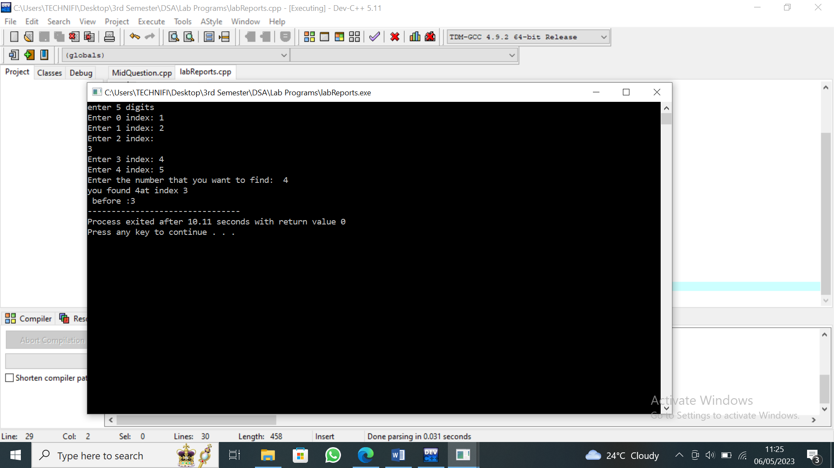
Lab report 2
Array Data Structure
Program 01
#include<iostream>
using namespace std;
main()
{
int x,pos,pos1,pos3,num,s;
cout<<"Enter the number of element u want to insert: \n";
cin>>x;
int arr[100];
cout<<"enter the valuess: \n";
for(int a=0;a<x;a++)
{
cin>>arr[a];
}
cout<<"enter the position of element: \n";
cin>>pos;
cout<<"enter value of element: \n";
cin>>num;
pos=pos-1;
for(int i=x;i>pos;i--)
{
arr[i]=arr[i-1];
}
arr[pos]=num;
x++;
for(int i=0;i<x;i++)
{
cout<<arr[i]<<endl;
}
cout<<"enter the position u want to search: \n";
cin>>pos1;
for(int i=0;i<x;i++)
{
if(pos1==arr[i]);
s++;
}
if(s==0)
{
cout<<"not found....";
}
else
{
cout<<"found...";
}
cout<<"enter value of element you want to delete: \n";
cin>>pos3;
pos3=pos3;
for(int i=pos3;i<x;i++)
{
arr[i]=arr[i+1];
}
x--;
cout<<"after deletion: \n";
for(int i=0;i<x;i++)
{
cout<<arr[i]<<" ";
}
}
Output:
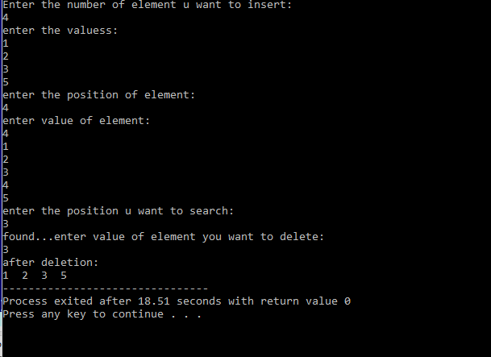
Binary
#include<iostream>
using namespace std;
main()
{
int count=0;
int loc;
int mid;
int arr[]={3,4,5,6,7,8,9};
cout<<"ENtre the number of search: \n";
int x;
cin>>x;
int low=0;
int high=6;
while(low<=high){
mid=(high+low)/2;
if(arr[mid]==x)
{
count=1;
loc=mid;
break;
}
if(arr[mid]<x){
low=mid+1;
}
else{
high=mid-1;
}
}
if(count==1)
{
cout<<"found at "<<mid;
}
else
{
cout<<"not found";
}
}

Output:
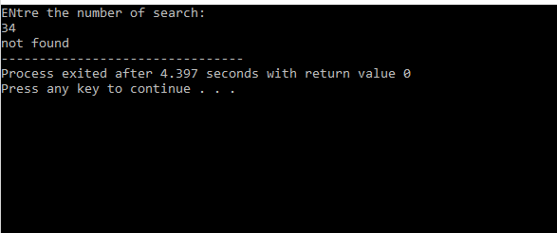
Lab 3
Link List Data Structure(1)
Program 01
#include<iostream>
using namespace std;
struct Node{
int data ;
Node* Next;
};
Node* create(int );
void show();
Node* start=NULL;
void insertBeg(Node*);
main(){
int n1,n2;
cout<<"Enter data ";
cin>>n1>>n2;
Node* ptr1 = create(n1);
Node* ptr2 = create(n2);
InsertBeg(ptr1);
InsertBeg(ptr2);
show();
}
Node* create(int n);
{
Node* ptr= new Node;
if(ptr==NULL){
cout<<"Memory full";
}
ptr->data=n;
ptr->Next=NULL;
return ptr;
}
void insertBeg(Node* p){
Node* temp;
if(start==NULL){
start=p;
}
else{
temp=start;
start=p;
p->Next=temp;
}
}
void show(){
Node* temp=start;
while(temp!=NULL){
cout<<temp->data;
temp=temp->Next;
}}
}
Output:
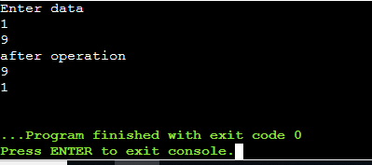
Lab 4
Link list Data Sturcture(2)
Program 01
#include<iostream>
using namespace std;
struct node{
int data;
node* next;
};
node* start=NULL;
node* creat(int);
void insertbeg(node*);
void insertend(node*);
void insertmid(int ,node*);
void show();
void deletbeg();
void deletend();
main()
{
int n1,n2,n3,n4,n;
cout<<"enter numbers: "<<endl;
cin>>n1>>n2>>n3>>n4;
node* p1=creat(n1);
node* p2=creat(n2);
node* p3=creat(n3);
node* p4=creat(n4);
insertbeg(p1);
insertbeg(p2);
insertend(p3);
cout<<"enter a position\n";
cin>>n;
cout<<"NOw.."<<endl;
insertmid(n,p4);
show();
cout<<"deletion at the begning"<<endl;
deletbeg();
show();
cout<<"deletion at the end"<<endl;
deletend();
show();
}
node* creat(int n)
{
node* p=new node;
if(p==NULL)
{
cout<<"memory is full: ";
}
p->data=n;
p->next=NULL;
return p;
}
void insertbeg(node* p)
{
node* tem;
if(start==NULL)
{
start=p;
}
else
{
tem=start;
start=p;
p->next=tem;
}
}
void insertend(node* p)
{
node* tem=start;
while(tem->next!=NULL)
{
tem=tem->next;
}
tem->next=p;
}
void insertmid(int n,node* p)
{
node* tem=start;
for(int i=1;i<n;i++)
{
tem=tem->next;
}
p->next=tem->next;
tem->next=p;
}
void show()
{
node* tem=start;
while(tem!=NULL)
{
cout<<tem->data<<endl;
tem=tem->next;
}
}
void deletbeg()
{
node* tem=start;
start=start->next;
delete tem;
}
void deletend()
{
node* end=start;
node* prev=start;
while(end->next)
{
prev=end;
end=end->next;
}
prev->next=NULL;
delete prev;
}
Output:
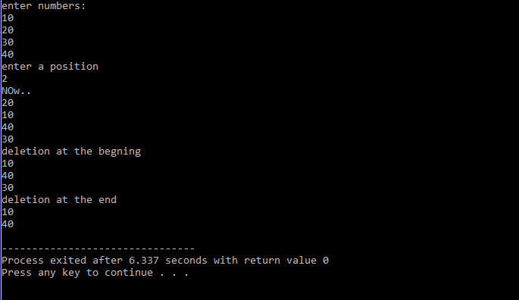
Lab 5
Program 01
#include<iostream>
using namespace std;
struct Node
{
int data;
Node* Next;
};
Node* create(int);
void show();
void search();
Node* Start=NULL;
void insertBeg(Node*);
void insertMid(int,Node*);
void insertEnd(Node*);
int main()
{
int n1,n2,n3,n4,pos;
cout<<"Enter the Data: ";
cin>>n1>>n2>>n3;
Node* ptr1 = create(n1);
Node* ptr2 = create(n2);
Node* ptr3 = create(n3);
insertBeg(ptr1);
insertBeg(ptr2);
insertBeg(ptr3);
cout<<" Enter Position: ";
cin>>pos;
cout<<" Now enter Value: ";
cin>>n4;
Node* ptr4 = create(n4);
insertMid(pos,ptr4);
show();
search();
}
Node* create(int n)
{
Node* ptr=new Node;
if(ptr==NULL)
{
cout<<" Memory Full";
}
else
{
ptr->data=n;
ptr->Next=NULL;
return ptr;
}
}
void show()
{
// Node* temp =Start;
// while(temp!=NULL)
// {
// cout<<temp->data<<endl;
// temp=temp->Next;
// }
cout<<Start->data<<endl;
Node* t=Start->Next;
cout<<t->data;
}
void seach()
{
int n,counter=0;
cout<<"\nEnter Number to Search: ";
cin>>n;
Node* temp =Start;
while(temp!=NULL)
{
if(n==temp->data)
{
cout<<"\nNumber found!";
counter++;
break;
}
else
temp=temp->Next;
}
if(counter==0)
{
cout<<"\nNumber not found!";
}
}
void insertBeg(Node* p)
{
Node* temp;
if(Start==NULL)
{
Start=p;
}
else
{
temp=Start;
Start=p;
p->Next=temp;
}
}
void insertEnd(Node* p)
{
Node* temp=Start;
Node* last;
if(Start==NULL)
{
Start=p;
}
else
{ do
{
if(temp->Next==NULL)
{
last=temp;
break;
}
else
temp=temp->Next;
}
while(temp!=NULL);
last->Next=p;
}
}
void insertMid(int c,Node* p)
{
Node* temp=Start;
for(int i=1; i<c;i++)
{
temp=temp->Next;
}
p->Next=temp->Next;
temp->Next=p;
}
Output:
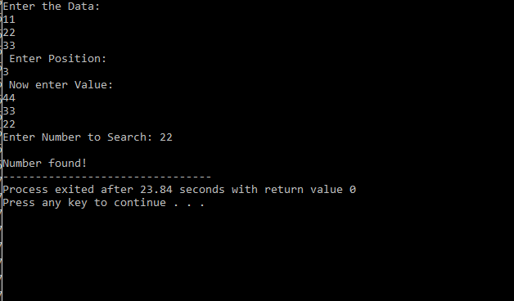
After swapping
void show()
{
cout<<Start->data<<endl; // start data
Node* temp =Start;
while(temp->Next!=NULL)
{
temp=temp->Next;
}
cout<<temp->data<<endl; // end data
cout<<"After swapping"<<endl;
Node* i=Start;
int swap;
int s2;
swap=i->data;
while(Start->Next!=NULL)
{
Start=Start->Next;
}
s2=Start->data;
swap=Start->data;
s2=i->data;
cout<<swap<<endl<<s2;
}

Middle……………………………………………………..
cout<<"middle"<<endl;
int count=0,mid;
Node* l1=Start;
while(l1!=NULL)
{
l1=l1->Next;
count++;

}
mid=count/2;
Node* loc=Start;
for(int i=1;i<mid;i++)
{
loc=loc->Next;
}
cout<<loc->data;

}
Lab 06
Circular Link List Data Structure

Circular linked list:
The circular linked list is a linked list where all nodes are connected to form a circle. In a circular linked list, the first node and the last node are connected to each other which forms a circle. There is no NULL at the end.
Program 1:
#include <iostream>
using namespace std;
struct Node {
int data;
Node* next;
};
Node* head = NULL;
Node* tail = NULL;
void addNode(int data) {
Node* newNode = new Node;
newNode->data = data;
newNode->next = NULL;
if (head == NULL) {
head = newNode;
tail = newNode;
}
else {
tail->next = newNode;
tail = newNode;
}
tail->next = head;
}
void displayList() {
Node* current = head;
if (head == NULL) {
cout << "List is empty." << endl;
}
else {
cout << "Nodes of the Circular Linked List:" << endl;
do {
cout << current->data << " ";
current = current->next;
} while (current != head);
}
}
int main() {
addNode(1);
addNode(2);
addNode(3);
addNode(4);
displayList();
}
Output:-
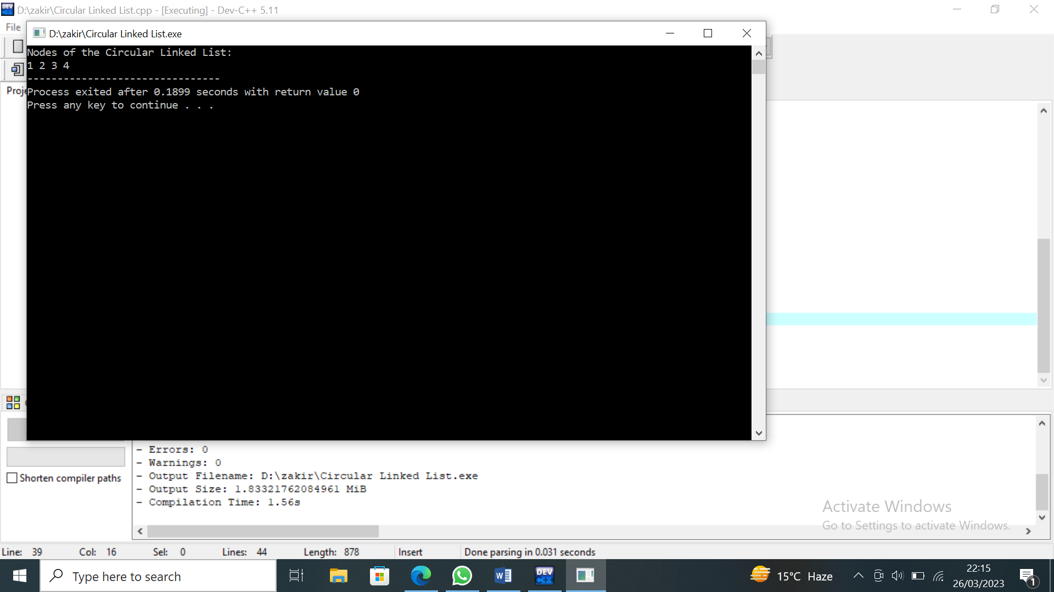
Lab 07
Stack Data Structure
Program 1:
#include<iostream>
using namespace std;
int stack[100];
int top=-1;
void push(int );
void pop();
void show();
main()
{
int n1,n2,n3,n4;
cout<<"enter the element of stack \n";
cin>>n1>>n2>>n3>>n4;
push(n1);
push(n2);
push(n3);
push(n4);
pop();
show();
}
void push(int n)
{
if(top==99)
cout<<"overflow";
top++;
stack[top]=n;
}
void pop()
{
if(top==-1)
{
cout<<"empty";
}
else
top--;
}
void show()
{
for(int i=0;i<=top;i++)
{
cout<<stack[i]<<endl;
}
}
Output:
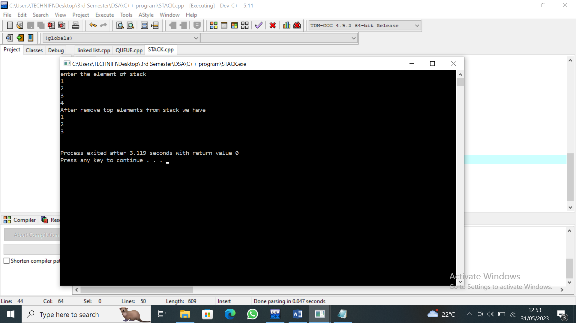
Lab 08
Queue Data Structure
Program 2:
#include<iostream>
using namespace std;
int que[100];
int rear=-1;
int front=-1;
void enque(int );
void deque();
void show();
main()
{
int n1,n2,n3,n4;
cout<<"enter the element of que \n";
cin>>n1>>n2>>n3>>n4;
enque(n1);
enque(n2);
enque(n3);
enque(n4);
deque();
show();
}
void enque(int n)
{
if(rear==99)
cout<<"overflow";
if(rear==-1)
front=0;
rear++;
que[rear]=n;
}
void deque()
{
if(front==-1||front>rear)
{
cout<<"empty";
}
front++;
}
void show()
{
cout<<"After remove of first elements"<<endl;
for(int i=front;i<=rear;i++)
{
cout<<que[i]<<endl;
}
}
Output:
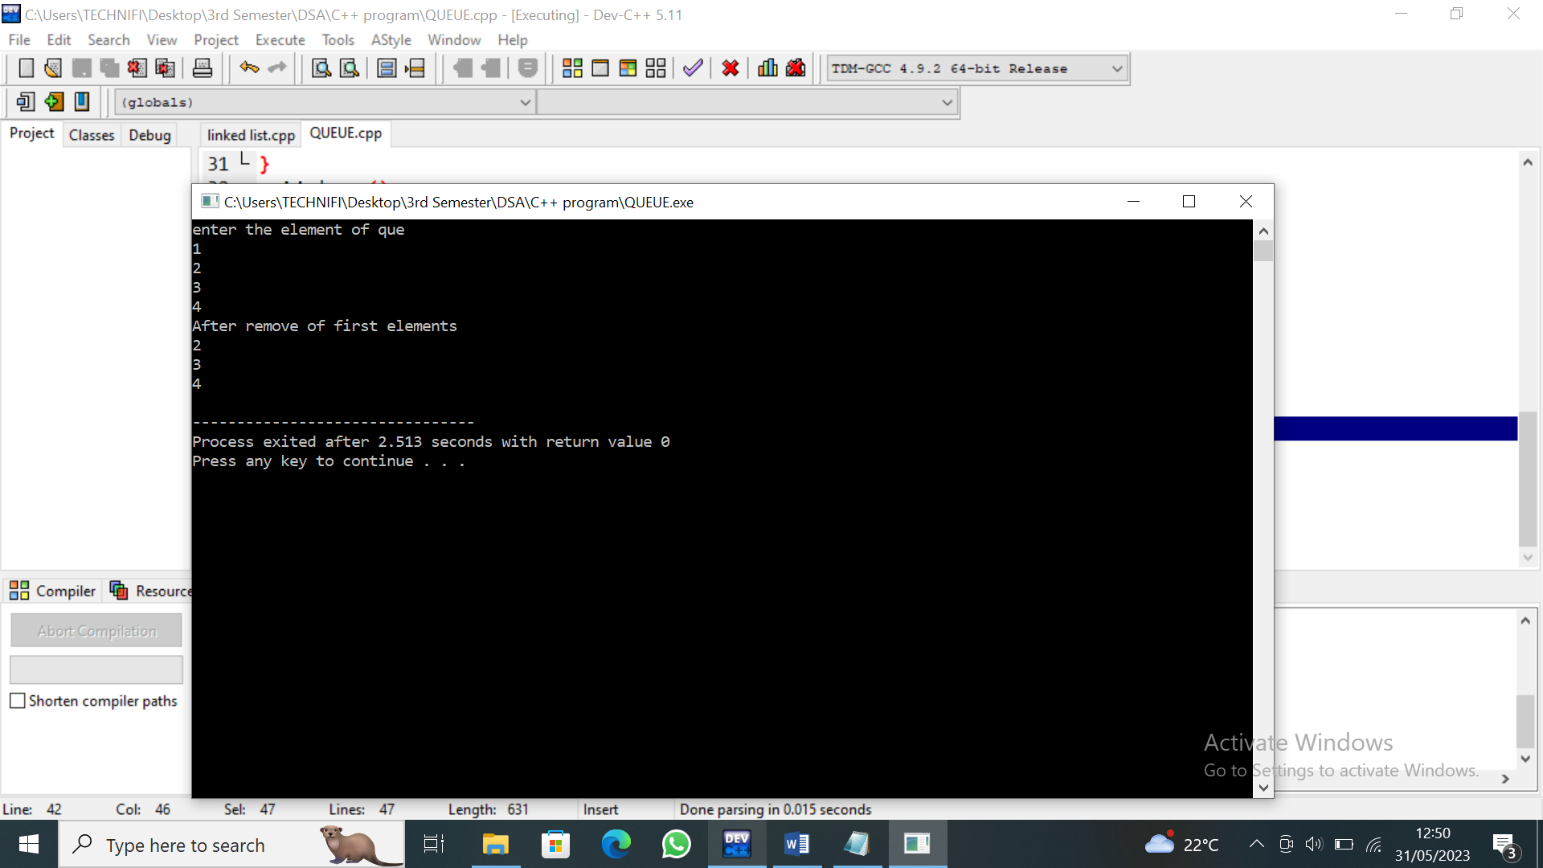
Program 3:
#include<iostream>
using namespace std;
int size=5 ;
int que[5];
int rear=-1int front=-1;
void enque(int );
void deque();
void show();
main()
{
int n1,n2,n3,n4,n5,n6,n7;
cout<<"enter the element of que \n";
cin>>n1>>n2>>n3>>n4>>n5>>n6>>n7;
enque(n1);
enque(n2);
enque(n3);
enque(n4);
enque(n5);
deque();
deque();
enque(n6);
enque(n7);
show();
}
void enque(int n)
{
if((rear==size-1 && front==0)||rear==front-1)
{
cout<<"overflow";
}
else if(rear==-1)
{
front=0;
rear++;
que[rear]=n;
}
else if(rear==size-1 && front>0)
{
rear=0;
que[rear]=n;

}
else
{
rear++;
que[rear]=n;
}
}
void deque()
{
if(front==-1)
{
cout<<"empty";
}
front++;

}
void show()
{
cout<<"\n OUTPUT \n";

if(front==-1)
{
cout<<"empty";
}
if(front>0)
{
for(int i=front;i<size;i++)
{
cout<<que[i]<<endl;
}
for(int i=0;i<=rear;i++)
{
cout<<que[i]<<endl;
}
}
else
{
for(int i=front;i<=rear;i++)
{
cout<<que[i]<<endl;
}
}
}
Output:
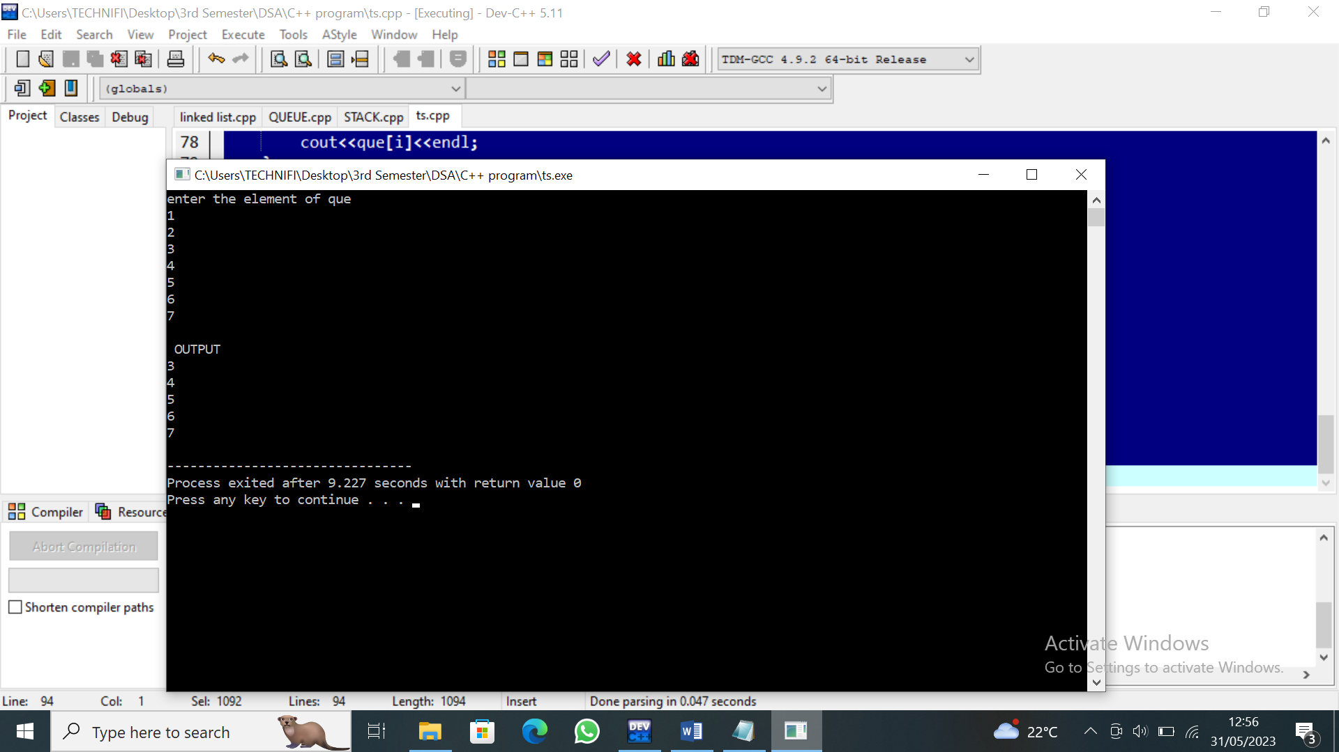
Lab 09
Program 1:
#include<iostream>
using namespace std;
struct node {
int data ;
node* next ;
node* prev ;
};
node* create(int);
void show();
node* start= NULL;
void insertbeg(node*);
int main()
{ int n1, n2;
cout<<" Enter data \n";
cin>>n1>>n2;
node* ptr1 = create(n1);
node* ptr2 = create(n2);
insertbeg(ptr1);
insertbeg(ptr2);
show();
}
node* create(int n){
node* ptr = new node ;
if(ptr == NULL)
{
cout<< " memeory full ";}
ptr->data=n;
ptr->next=NULL;
ptr->prev=NULL;
return ptr; }
void insertbeg(node* p)
{ node* temp;
if(start== NULL){
start = p; }
else {
temp= start;
temp->prev= p;
start= p;
p->next= temp; } }
void show (){
node* temp;
node* q = start;
cout<<" Inserted Elements \n";
while(q !=NULL){
cout<< q->data<<endl;
temp=q;
q= q->next; }
cout<<" Reverse Elements \n";
while(temp !=NULL){
cout<<temp->data<<endl;
temp= temp->prev;
} }
Output:
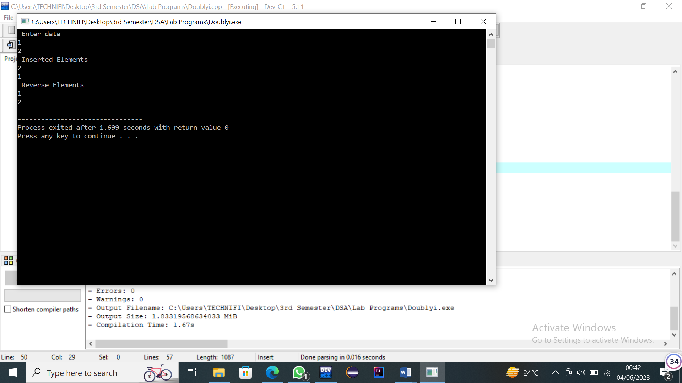
Program 2:
#include<iostream>
using namespace std;
struct node {
int data ;
node* next ;
node* prev ;
};
node* create(int);
void show();
node* start= NULL;
void insertbeg(node*);
void insertend(node*);
void insertmid(int,node*);
void delbeg();
void delend();
void delmid(int);
int main()
{ int n1, n2,n3,n4,n,x ;
cout<<" Enter data \n";
cin>>n1>>n2>>n3;
cout<<" enter position after you want to insert ";
cin>>n;
cout<<" enter value ";
cin>>n4;
node* ptr1 = create(n1);
node* ptr2 = create(n2);
node* ptr3 = create(n3);
node* ptr4 = create(n4);
insertbeg(ptr1);
insertbeg(ptr2);
insertend(ptr3);
insertmid(n,ptr4);
show();
delbeg();
cout<<"After delete beggining\n\n";
show();
delend();
cout<<"After delete End \n\n";
show();
cout<<"Enter position After you want to delete \n\n";
cin>>x;
delmid(x);
show();
}
node* create(int n){
node* ptr = new node ;
if(ptr == NULL)
{
cout<< " memeory full ";}
ptr->data=n;
ptr->next=NULL;
ptr->prev=NULL;
return ptr; }
void insertbeg(node* p)
{ node* temp;
if(start== NULL){
start = p; }
else {
temp= start;
temp->prev= p;
start= p;
p->next= temp; } }
void insertend(node* p){
node* temp=start;
while(temp->next !=NULL){
temp= temp->next;}

temp->next=p;
p->prev=temp;}
void insertmid(int x,node* p){
node* temp=start;
for(int i=1; i<x; i++){
temp=temp->next; }
p->next=temp->next;
temp->next=p;
p->prev=temp;
}
void show (){
node* temp;
node* q = start;
cout<<" Inserted Elements \n";
while(q !=NULL){
cout<< q->data<<endl;
temp=q;
q= q->next; }}
void delbeg(){
node* temp;
start= start->next;
start->prev=NULL;
delete temp;}
void delend(){
node* temp;
node* loc;
while(temp->next !=NULL){
temp=temp->next; }
loc=temp->prev;
delete temp;
loc->next=NULL;
}
void delmid(int x){
node* temp= start;
for(int i=1; i<x; i++){
temp=temp->next; }
node* del = temp->next;
node* p2=del->next;
node* p1=del->prev;
p1->next=p2;
p2->prev=p1;
delete del; }
Output:
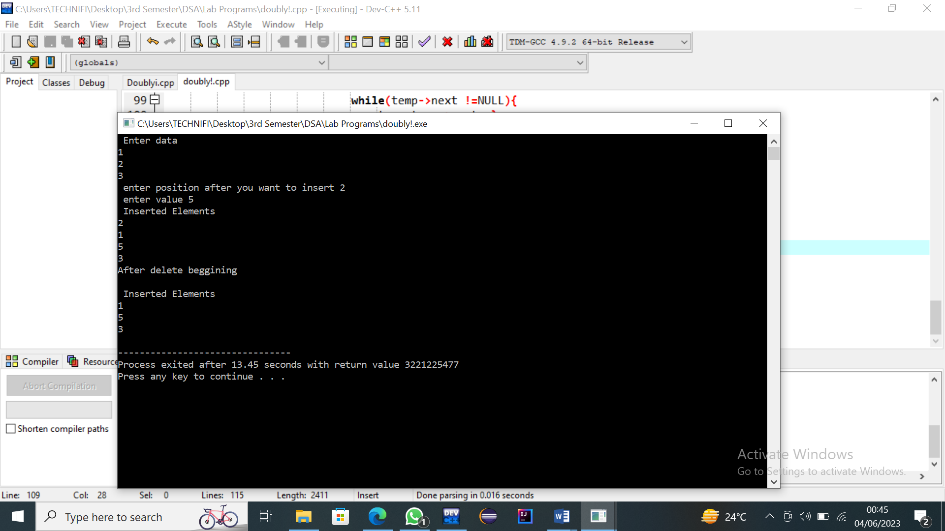
Lab 10
Bubble Sort
#include <iostream>
using namespace std;
int main() {
int arr[] = {64, 34, 25, 12, 22, 11, 90};
int size = sizeof(arr) / sizeof(arr[0]);

cout << "Original array: ";
for (int i = 0; i < size; i++) {
cout << arr[i] << " ";
}
cout << std::endl;
for (int i = 0; i < size - 1; i++) {
for (int j = 0; j < size - i - 1; j++) {
if (arr[j] > arr[j + 1]) {
// Swap arr[j] and arr[j+1]
int temp = arr[j];
arr[j] = arr[j + 1];
arr[j + 1] = temp;
}
}
}
cout << "Sorted array: ";
for (int i = 0; i < size; i++) {
cout << arr[i] << " ";
}
cout << endl;
return 0;
}

Output:
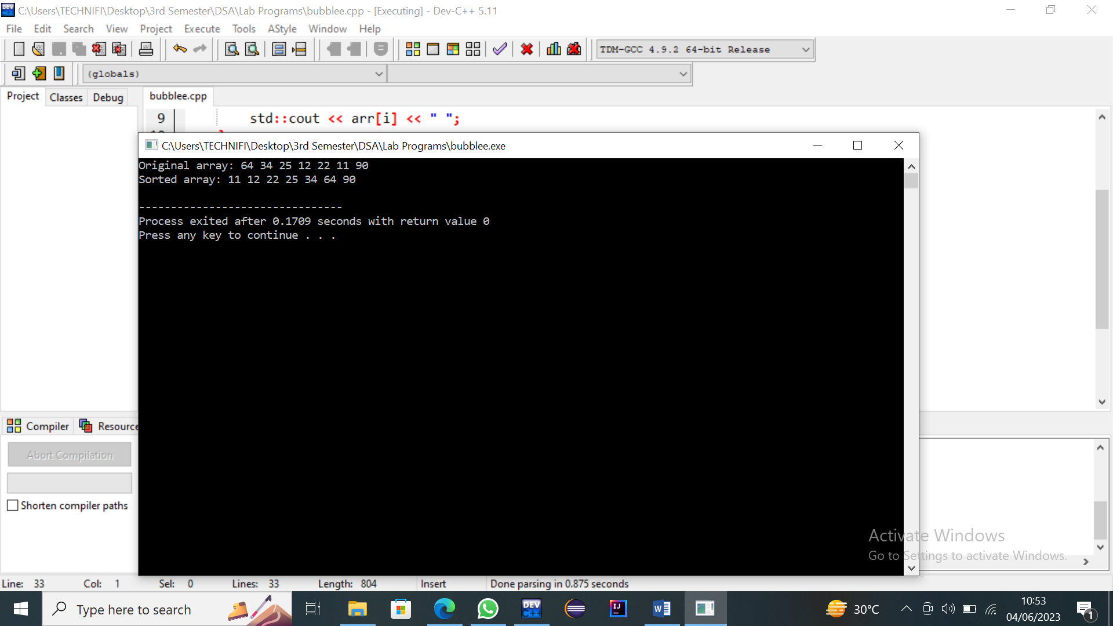
Selection Sort
#include <iostream>
Using namespace std;
int main() {
int arr[] = {64, 34, 25, 12, 22, 11, 90};
int size = sizeof(arr) / sizeof(arr[0]);
cout << "Original array: ";
for (int i = 0; i < size; i++) {
cout << arr[i] << " ";
}
cout << std::endl;
// Selection sort algorithm
for (int i = 0; i < size - 1; i++) {
int minIndex = i;
for (int j = i + 1; j < size; j++) {
if (arr[j] < arr[minIndex]) {
minIndex = j;
}
}
// Swap arr[i] and arr[minIndex]
int temp = arr[i];
arr[i] = arr[minIndex];
arr[minIndex] = temp;
}
cout << "Sorted array: ";
for (int i = 0; i < size; i++) {
cout << arr[i] << " ";
}
cout << endl;
return 0;
}
Output:
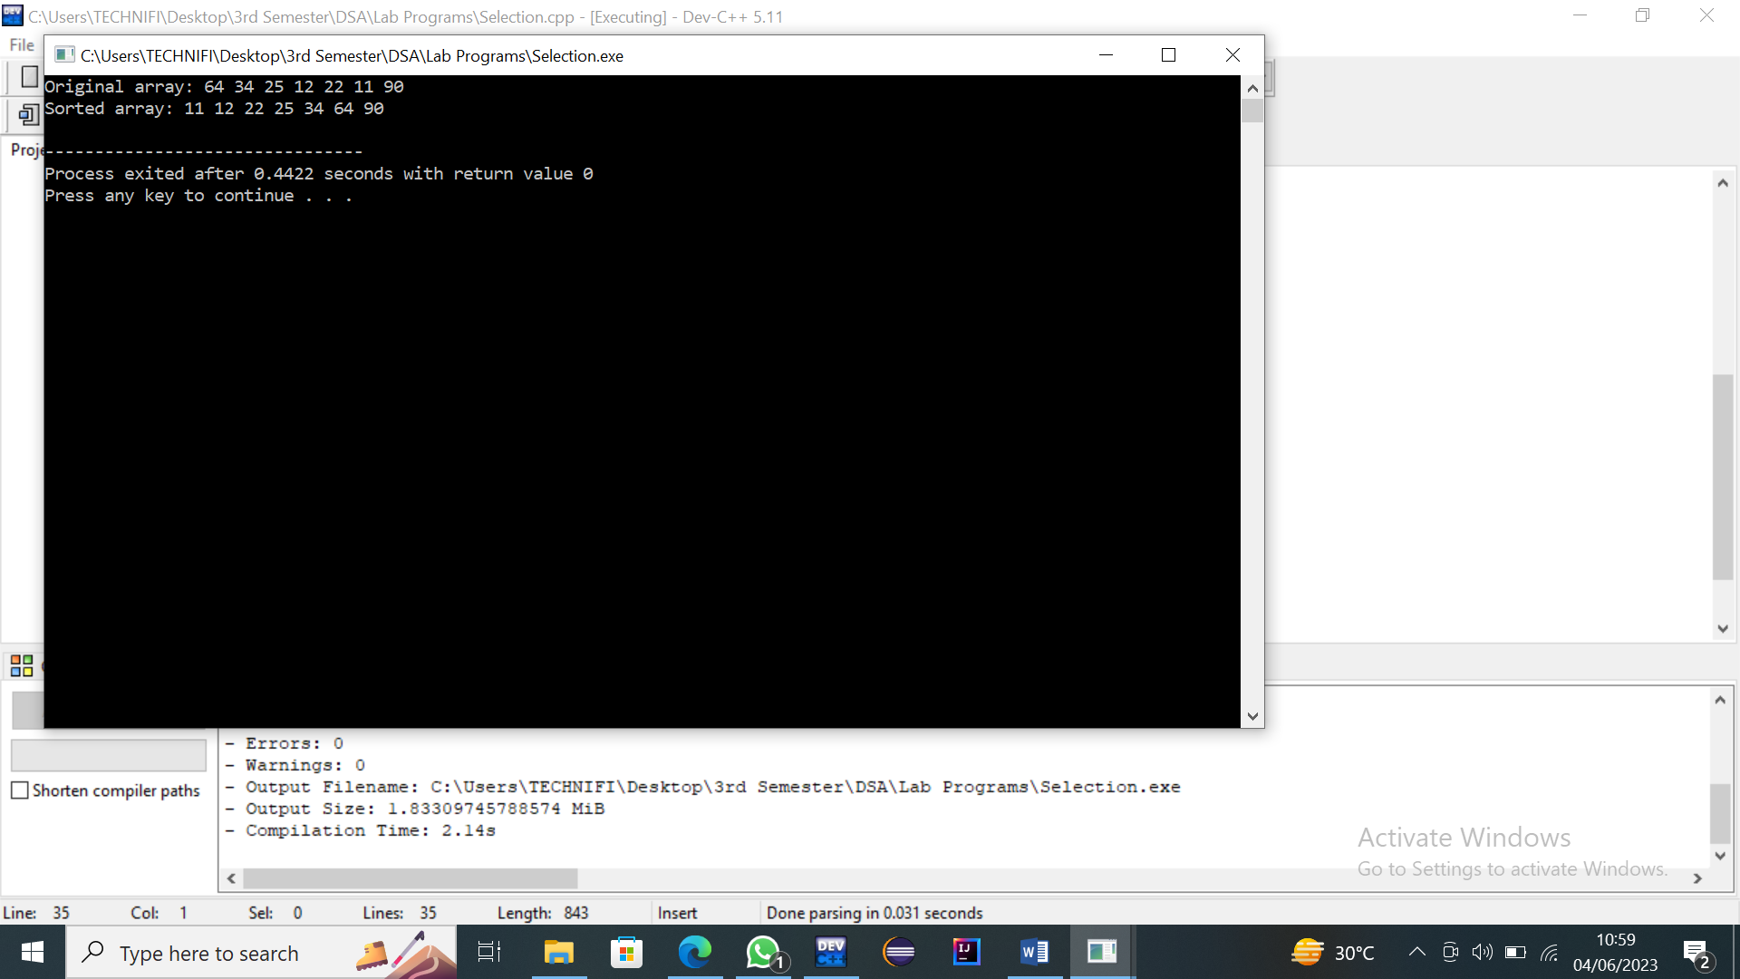

Lab 11

Insertion Sort
#include <iostream>
using namespace std;
int main() {
int arr[] = {64, 34, 25, 12, 22, 11, 90};
int size = sizeof(arr) / sizeof(arr[0]);
cout << "Original array: ";
for (int i = 0; i < size; i++) {
cout << arr[i] << " ";
}
cout <<endl;
// Insertion sort algorithm
for (int i = 1; i < size; i++) {
int key = arr[i];
int j = i - 1;
while (j >= 0 && arr[j] > key) {
arr[j + 1] = arr[j];
j--;
}
arr[j + 1] = key;
}
cout << "Sorted array: ";
for (int i = 0; i < size; i++) {
cout << arr[i] << " ";
}
cout << std::endl;
return 0;
}
Output:
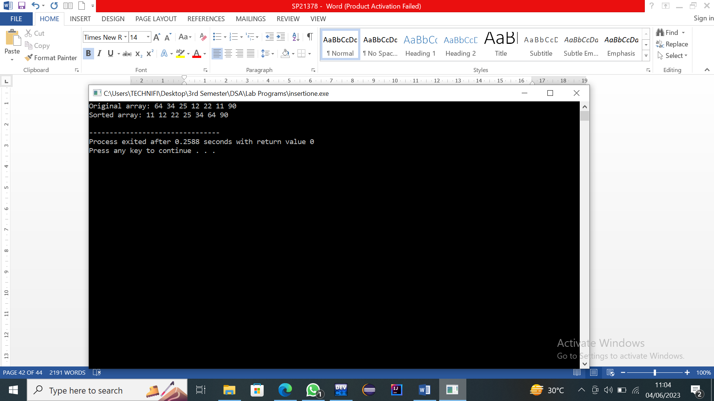
Shell Sort
#include<iostream>
using namespace std;
void shellsort(int arr[], int n);
int main(){
int n;
int arr[ n];
cout<<"Enter size of an array :";
cin>>n;
for(int i = 0; i<n; i++){
cin>>arr[i];
}
cout<<endl<<"Before sorting the element:\n ";
for(int i = 0; i<n; i++){
cout<<arr[i]<<" ";
}
cout<<endl<<endl<<"SHELL SORT "<<endl;
shellsort(arr, n);
cout<<endl<<"After shell sort: \n";
for(int i = 0; i<n; i++){
cout<<arr[i]<<" ";
}
return 0;
}
void shellsort(int arr[], int n) {
for (int gap = n / 2; gap > 0; gap /= 2) {
for (int i = gap; i < n; i++) {
int temp = arr[i];
int j;
for (j = i; j >= gap && arr[j - gap] > temp; j -= gap) {
arr[j] = arr[j - gap];
}
arr[j] = temp;
}
}
}

Output:
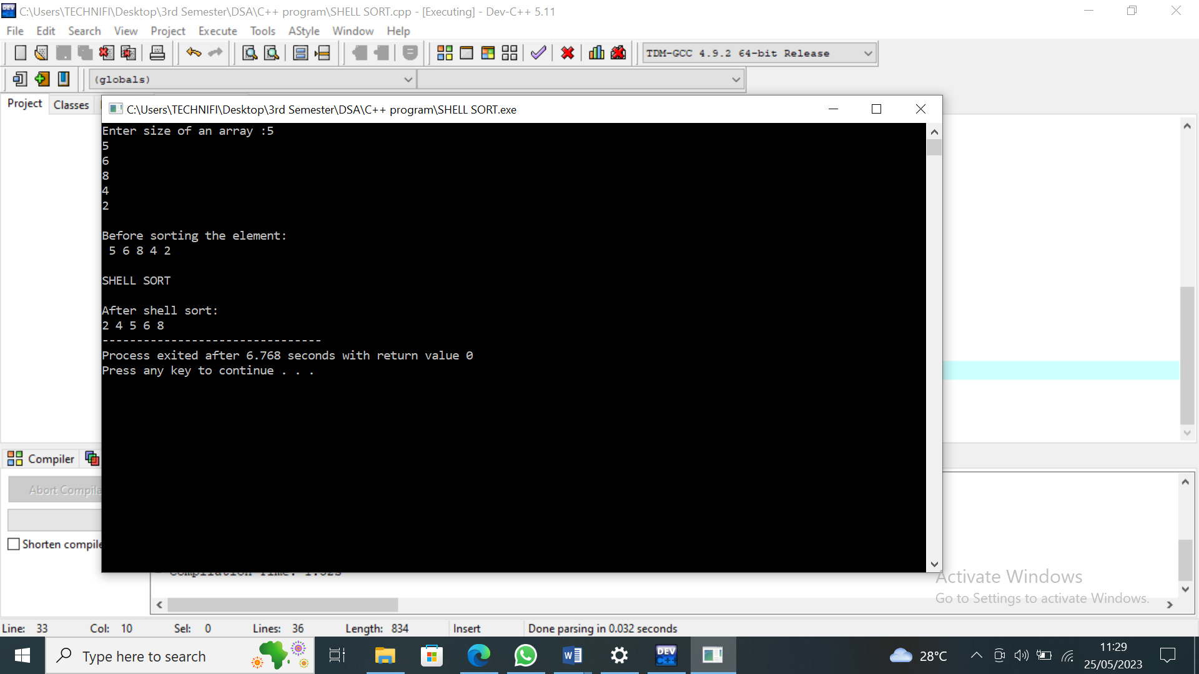
Lab 12
Factorial With Recursion
Program 1:
#include<iostream>
using namespace std;
int fac(int);
main()
{
int n;
cout<<"Enter a number: ";
cin>>n;
cout<<fac(n);

}
int fac(int a)
{
if(a==1)
return 1;
else
return a*fac(a-1);
}
Output:
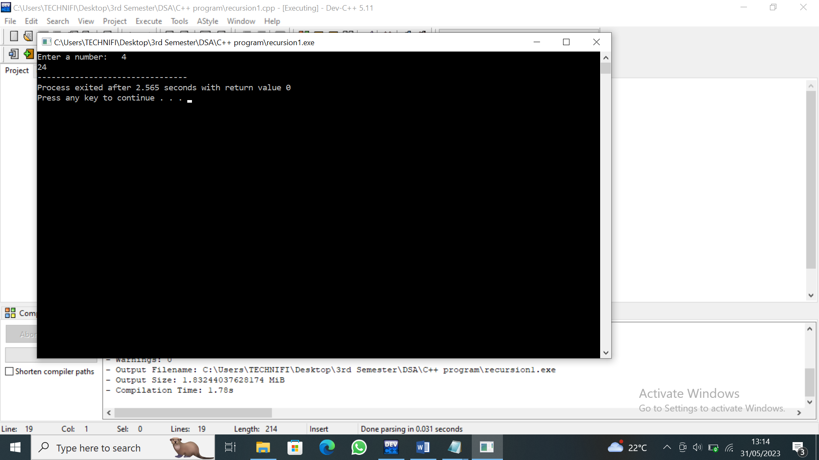
Program 2:
#include<iostream>
using namespace std;
int fac(int);
main()
{
int n;
cout<<"Enter a number: ";
cin>>n;
cout<<fac(n);

}
int fac(int a)
{
if(a==0)
return 0;
else
return a+fac(a-10);
}

Output:
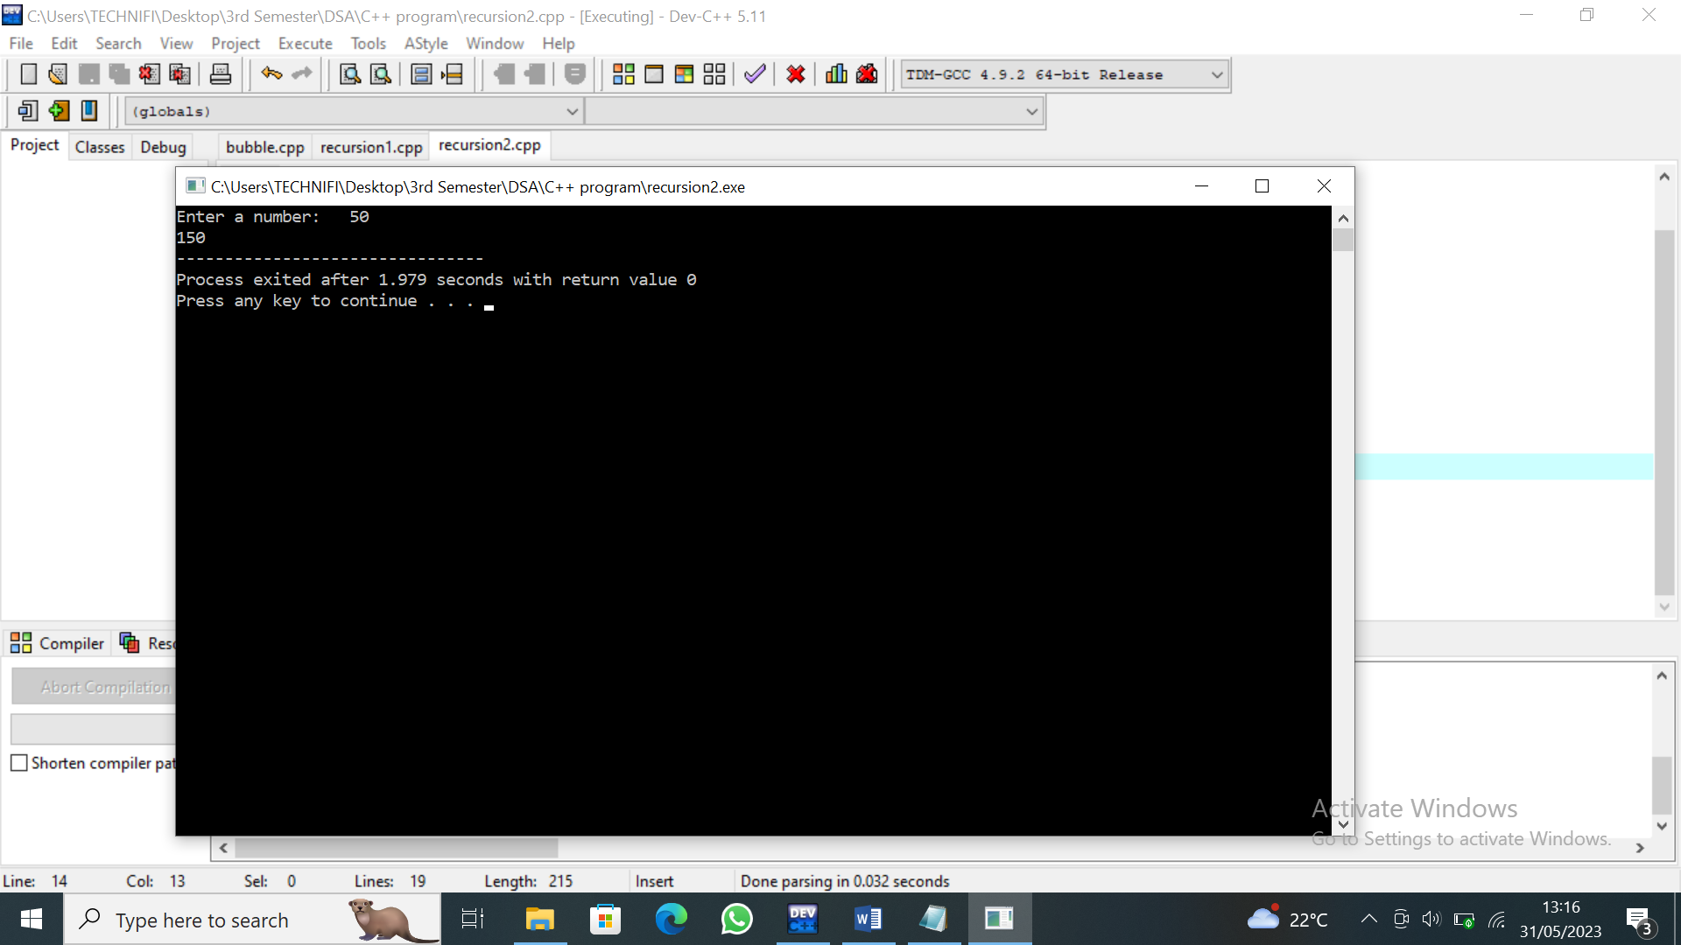

Lab 13
Tree Insertion
#include<iostream>
using namespace std;
struct Node {
int data;
struct Node *left;
struct Node *right;
};

void show(Node *root) {
if(root == NULL) return;

cout<<"\n"<<root->data;
show(root->left);
show(root->right);
}
Node* Insert(Node *root,char data) {
if(root == NULL) {
root = new Node();
root->data = data;
root->left = root->right = NULL;
}
else if(data <= root->data)
root->left = Insert(root->left,data);
else
root->right = Insert(root->right,data);
return root;
}

int main() {
Node* root = NULL;
root = Insert(root,5); root = Insert(root,10);
root = Insert(root,3); root = Insert(root,4);
root = Insert(root,1); root = Insert(root,11);
cout<<"\nOut put\n: ";
show(root);
cout<<"\n";
}
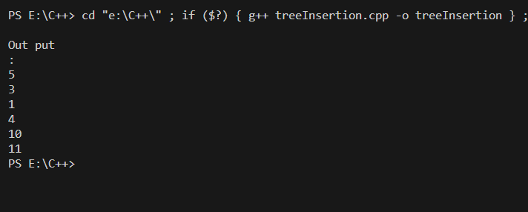

Lab 14
Write a program using Deletion in a Binary search tree.
#include<iostream>
using namespace std;
struct Node {
int data;
struct Node *left;
struct Node *right;
};
Node* FindMin(Node* root)
{
while(root->left != NULL) root = root->left;
return root;
}
struct Node* Delete(struct Node *root, int data) {
if(root == NULL) return root;
else if(data < root->data) root->left = Delete(root->left,data);
else if (data > root->data) root->right = Delete(root->right,data);
else {
if(root->left == NULL && root->right == NULL) {
delete root;
root = NULL;
}
else if(root->left == NULL) {
struct Node *temp = root;
root = root->right;
delete temp;
}
else if(root->right == NULL) {
struct Node *temp = root;
root = root->left;
delete temp;
}
else {
struct Node *temp = FindMin(root->right);
root->data = temp->data;
root->right = Delete(root->right,temp->data);
}
}
return root;
}
void Inorder(Node *root) {
if(root == NULL) return;

Inorder(root->left);
printf("%d ",root->data);
Inorder(root->right);
}
Node* Insert(Node *root,char data) {
if(root == NULL) {
root = new Node();
root->data = data;
root->left = root->right = NULL;
}
else if(data <= root->data)
root->left = Insert(root->left,data);
else
root->right = Insert(root->right,data);
return root;
}

int main() {
Node* root = NULL;
root = Insert(root,5); root = Insert(root,10);
root = Insert(root,3); root = Insert(root,4);
root = Insert(root,1); root = Insert(root,11);
root = Delete(root,5);
cout<<"Inorder: ";
Inorder(root);
cout<<"\n";
}
